Hemodialysis and Peritoneal Dialysis Market ( 2025 to 2035)
Market Size, Market Share, Market Volume, AGR%, CAGR%, Market Share, Strategic Drivers, Trends, Opportunities, Production, Trade Analysis, Value Chain, Market Trends, By Dialysis Type, By Product Type, By Modality, By End User, By Age Group, By Indication, By Technology, By Service Type, By Geographical Regions, Competitive Analysis, Recent Activities, Patient Analysis, Clinical Trails, Consultation & Advisory Services, and more.

Years | 2022 | 2023 | 2024 | 2025 | 2026 | 2027 | 2028 | 2029 | 2030 | 2031 | 2032 | 2033 | 2034 | 2035
Revenue (USD Bn) | XX | XX | XX | XX | XX | XX | XX | XX | XX | XX | XX | XX | XX | XX

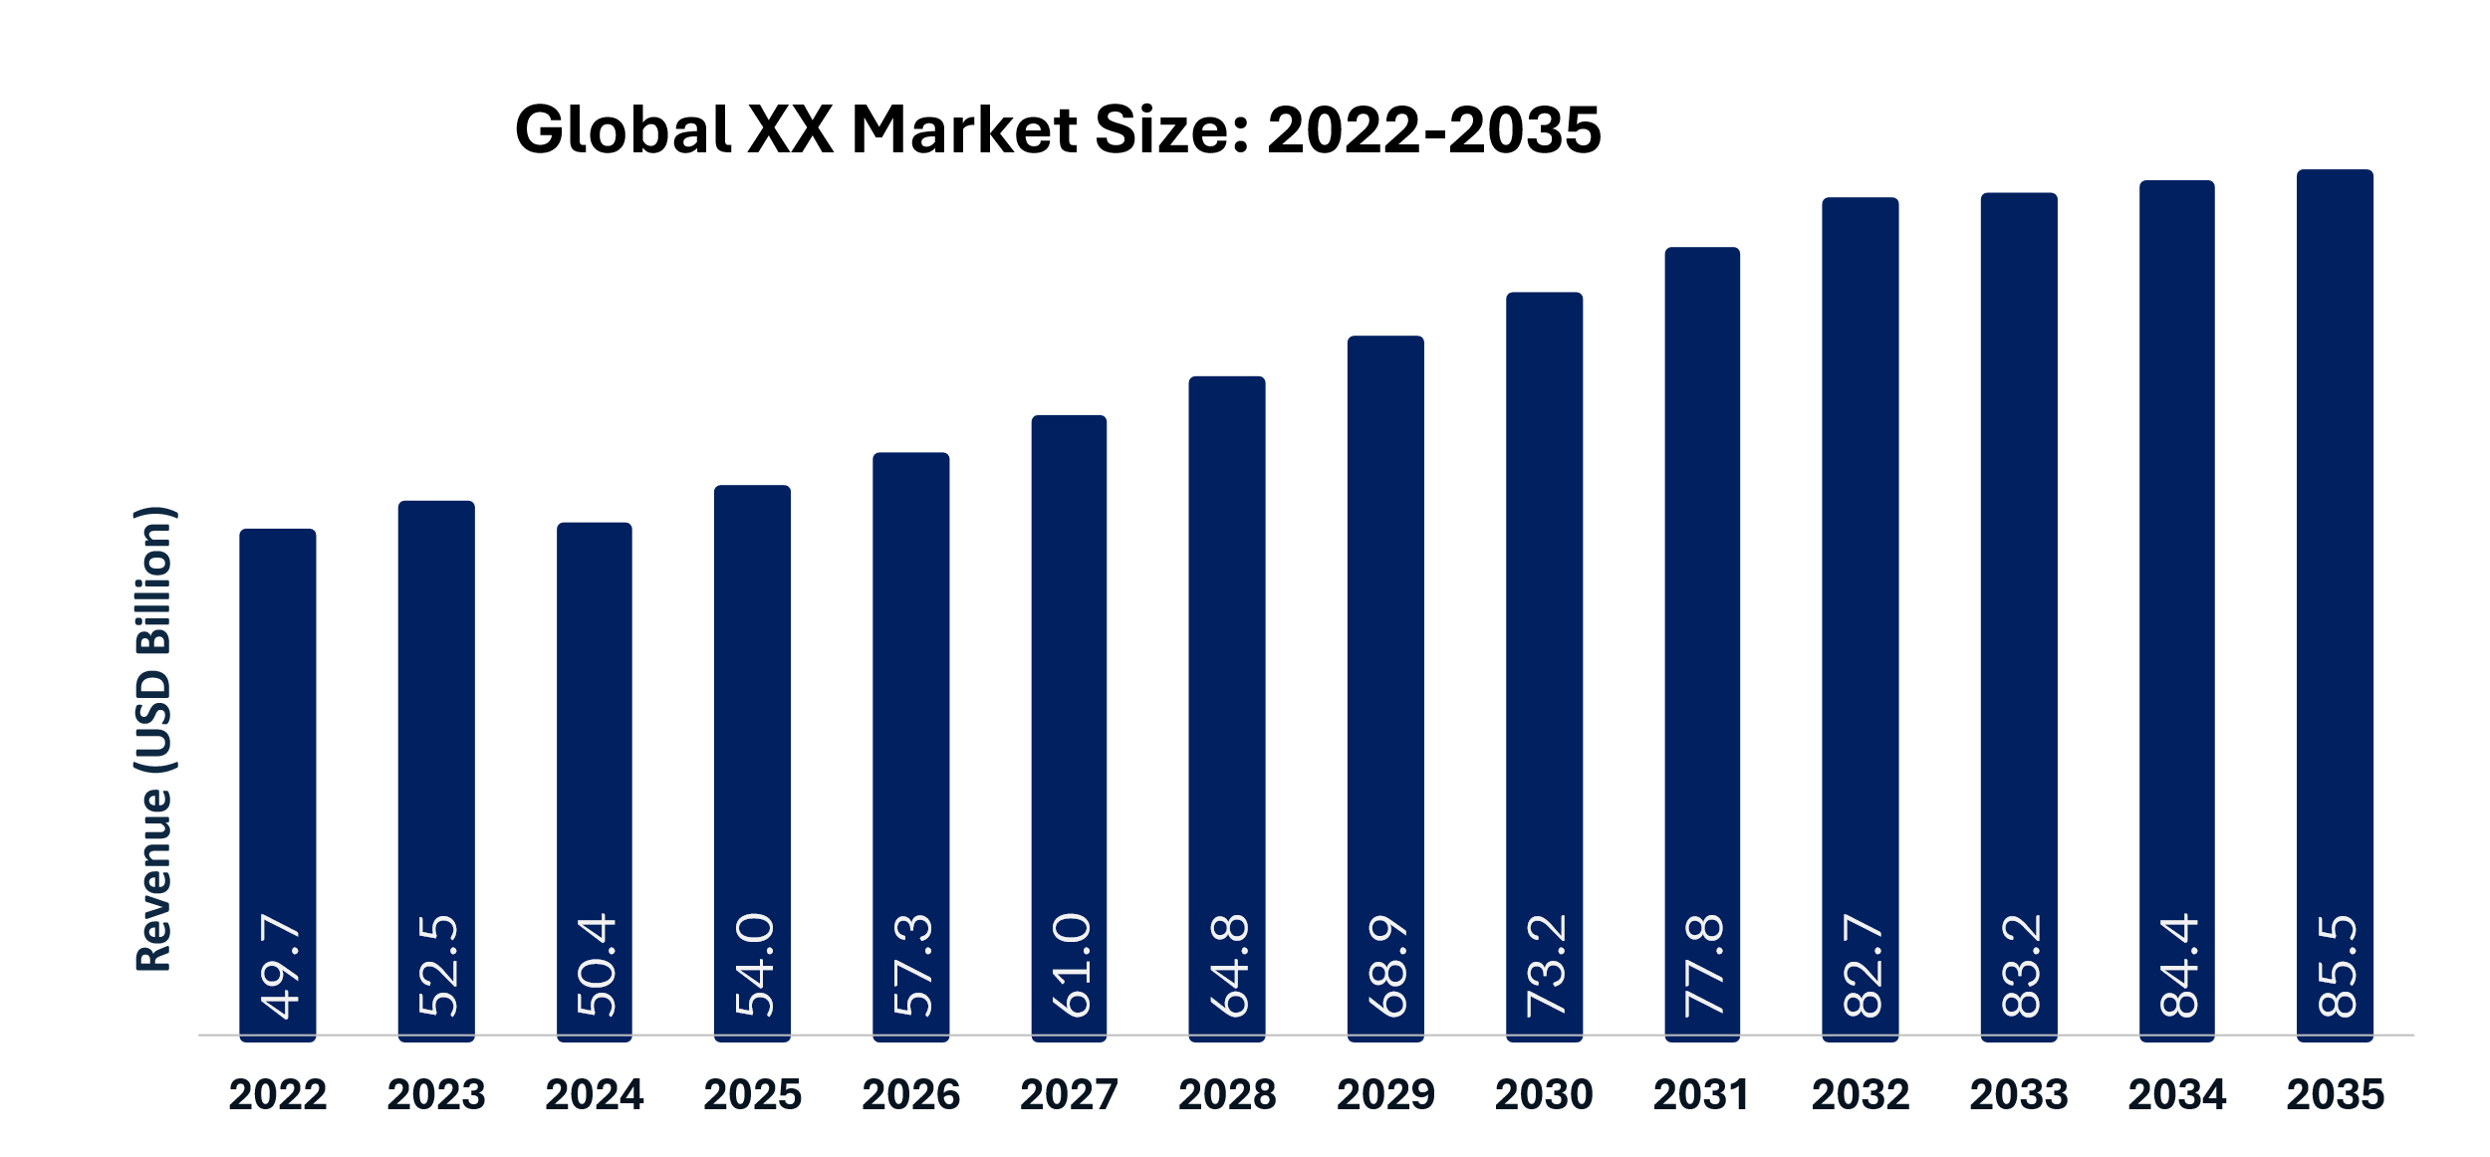
Hemodialysis and Peritoneal Dialysis Market Summary:
The global hemodialysis and peritoneal dialysis market size was estimated at USD XX billion in 2025 and is projected to reach USD XX billion by 2033, growing at a CAGR of XX% from 2026 to 2033. The demand for hemodialysis and peritoneal dialysis is driven by several factors, including the rising incidence of acute kidney injury, the scarcity of organ donors, the risks associated with transplants, technological advancements, and initiatives by leading players to introduce advanced products and services.
Key Market Takeaways & Insights:
· North America Hemodialysis and Peritoneal Dialysis Market held the largest share of the global market in 2025, supported by a large dialysis patient population, advanced renal care infrastructure, and favorable reimbursement policies.
· The Asia Pacific Hemodialysis and Peritoneal Dialysis Market is expected to grow significantly during the forecast period due to the rising burden of chronic kidney disease (CKD), increasing healthcare investments, and expanding government dialysis programs.
· By Dialysis Type: Segments the market based on the primary renal replacement therapy, including hemodialysis and peritoneal dialysis, with hemodialysis accounting for the largest share due to its widespread clinical adoption.
· By Product Type: Categorizes the market into dialysis machines, dialyzers, consumables, catheters, and accessories, driven by the increasing demand for advanced dialysis equipment and recurring consumables.
· By Technology: Segments the market based on technological advancements, including conventional dialysis systems, wearable dialysis devices, smart monitoring systems, and remote patient management technologies.
· By Modality: Divides the market into in-center dialysis, home dialysis, continuous ambulatory peritoneal dialysis (CAPD), and automated peritoneal dialysis (APD), reflecting the growing shift toward patient-centric home therapies.
· By Age Group: Classifies patients into pediatric, adult, and geriatric populations, with the adult and elderly groups representing the largest demand due to the rising prevalence of chronic kidney disease.
· By Service Type: Divides the market into in-center dialysis services, home dialysis services, maintenance dialysis, and remote patient support services, supported by increasing investments in integrated renal care.
· By Indication: Categorizes the market according to diseases requiring dialysis, such as chronic kidney disease (CKD), end-stage renal disease (ESRD), and acute kidney injury (AKI), with CKD and ESRD accounting for the majority of treatments.
· By End User: Segments the market by healthcare setting, including hospitals, dialysis centers, and home care settings, with dialysis centers remaining the dominant end users because of high treatment volumes.
Market Intelligence Overview (Historical, Current, Forecast):
- 2025 Hemodialysis and Peritoneal Dialysis Market Size: USD XX Billion
- 2035 Hemodialysis and Peritoneal Dialysis Market Size: USD XX Billion
Region | 2022 | 2023 | 2024 | 2025 | 2026 | 2027 | 2028 | 2029 | 2030 | 2031 | 2032 | 2033 | 2034 | 2035
North America | XX | XX | XX | XX | XX | XX | XX | XX | XX | XX | XX | XX | XX | XX
Europe | XX | XX | XX | XX | XX | XX | XX | XX | XX | XX | XX | XX | XX | XX
Asia Pacific | XX | XX | XX | XX | XX | XX | XX | XX | XX | XX | XX | XX | XX | XX
Latin America | XX | XX | XX | XX | XX | XX | XX | XX | XX | XX | XX | XX | XX | XX
Middle East & Africa | XX | XX | XX | XX | XX | XX | XX | XX | XX | XX | XX | XX | XX | XX
- Hemodialysis and Peritoneal Dialysis Market CAGR (2026-2035): XX%
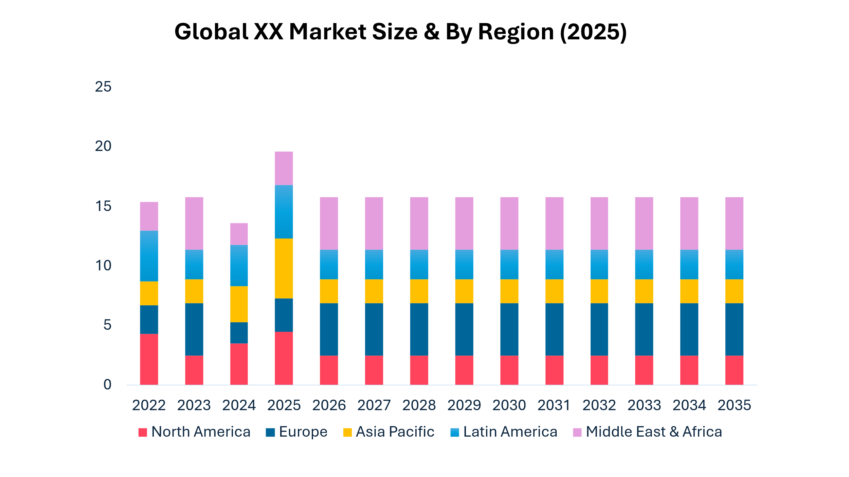
Disease Epidemiology Analysis:
• Chronic Kidney Disease (CKD) prevalence & incidence trends
• End-Stage Kidney Disease (ESKD) patient population analysis
• Demographic burden assessment (aging population, diabetes & hypertension patients)
• Regional distribution of dialysis-dependent patients
Treatment Landscape Overview:
• Standard dialysis treatment and renal replacement therapy (RRT) analysis
• Current hemodialysis and peritoneal dialysis treatment pathways
• Unmet needs in dialysis access, affordability, and patient outcomes
• Comparative positioning of hemodialysis and peritoneal dialysis therapies

 | 2025 | 2026 | 2027 | 2028 | 2029 | 2030 | 2031 | 2032 | 2033 | 2034 | 2035
Conservative | XX | XX | XX | XX | XX | XX | XX | XX | XX | XX | XX
Likely | XX | XX | XX | XX | XX | XX | XX | XX | XX | XX | XX
Optimistic | XX | XX | XX | XX | XX | XX | XX | XX | XX | XX | XX

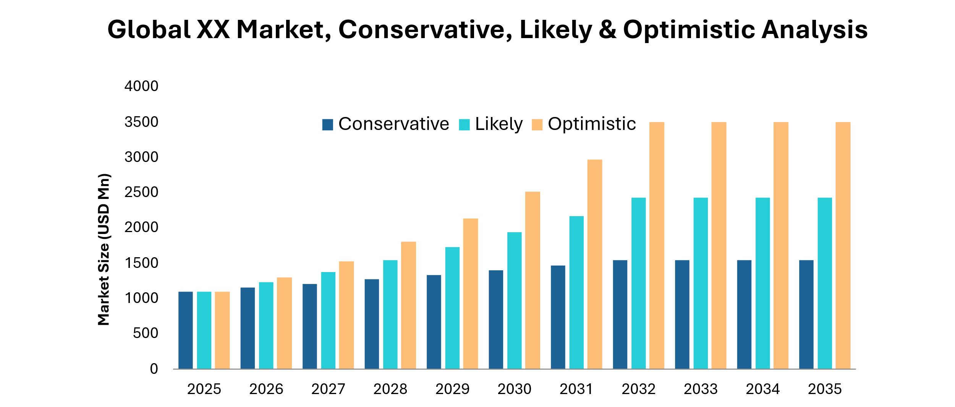
Market Dynamics:
Market Drivers:
Rising Investments in Smart, Bionic and Artificial Intelligence-Powered Prosthetics
The growing investments in the area of intelligent, bionic, and AI-based prosthetic solutions are bringing many business opportunities in the market of prosthetic and orthotic devices. New developments based on 3D printing of robotized artificial limbs fitted with muscle sensors and adaptive grip controlled by means of an AI-powered control system are introducing new changes in the field of prosthetics. Open Bionics released its Hero FLEX in 2026, which is a new bionic arm designed specifically for those people who lost their arms above the elbow joint. The new development is based on AI-powered technologies enabling the recognition of muscle signals. Link
Increasing Incidence of End-Stage Renal Disease (ESRD) and Chronic Kidney Disease(CKD)
One of the reasons that have contributed significantly to the growth of the Hemodialysis and Peritoneal Dialysis market is the increasing prevalence of chronic kidney diseases (CKDs) and end-stage renal diseases (ESRDs). The prevalence of conditions such as diabetes, hypertension, obesity, and aged population has increased the number of individuals requiring kidney replacement therapy. According to the report by the Pradhan Mantri National Dialysis Programme of the Government of India, approximately 2,330 USD new cases of ESRD are reported annually in India, and hence a need for XX $ worth of dialysis treatment arises. The need for dialysis increases with the deteriorating health of kidneys, which makes it imperative for individuals to undergo hemodialysis and peritoneal dialysis. The rising number of individuals is prompting various authorities to set up dialysis centers. One of the aims of setting up the PMNDP of India is to provide dialysis at lower prices through government healthcare centers. Link
Market Restraint:

Infection and Treatment Related Risks

Infections and complications related to dialysis constitute significant impediments to acceptance of hemodialysis and peritoneal dialysis treatment methods. The patients on hemodialysis therapy face the risk of blood infection through the frequent insertion of the device in blood vessels. However, those receiving peritoneal dialysis are prone to the condition of peritonitis where there is an infection in the abdominal lining. According to the United States CDC, infections are the major causes of hospitalization and death among patients on dialysis therapy. These cause high expenses of health care, reduced quality of life and even the need to change the dialysis method. For example, a patient undergoing peritoneal dialysis with peritonitis needs to be admitted to the hospital and undergo hemodialysis. Link

Dialysis Supply Chain Disruptions and Equipment Shortages
The Hemodialysis and Peritoneal Dialysis markets are dependent on the existence of supply such as blood lines, dialyzers, catheters, and dialysis fluid among others. Disruption of the supply will definitely affect the provision of services to patients and operations in the healthcare facilities. In March 2025, there was an FDA alert about shortage of hemodialysis blood lines and this posed a risk of disruptions in providing care to patients under chronic hemodialysis. For example, in American dialysis centers, the FDA instructed that conservative actions be taken due to scarcity of blood lines. Link
Market Opportunities:
Increasing Use of Telehealth and Remote Patient Monitoring in Home Dialysis
There have been more inclusions of telehealth and remote patient monitoring in the process of providing home dialysis. Telemedicine would help in better patient monitoring, early detection of problems, communication between the patients and healthcare professionals, and better patient compliance during home dialysis. With the increasing trend in health care that discourages hospital visits and puts the convenience of the patient first, there will be more adoption of telemedicine technology in the management of chronic ailments such as kidney diseases.
For example, a person who has to undergo peritoneal dialysis can easily send his information to the doctors available through the use of remote technology, and this ensures that preventive steps are taken immediately to prevent any deterioration in his condition. This gives rise to an opportunity for the manufacturers of remote dialysis systems. Link

Expansion of Home-Based Dialysis Programs
The increasing use of home dialysis therapy creates massive business opportunities for the hemodialysis and peritoneal dialysis market. The home dialysis therapies including peritoneal dialysis and home hemodialysis have more convenience and freedom compared to the conventional dialysis therapies. The rising investment in healthcare, the increasing prevalence of CKD, and the need to reduce stress in healthcare facilities is pushing nations to promote home dialysis treatments to patients. Another factor fueling the growth of home dialysis services is the innovations in portable dialysis technologies and patient education programs.
For example, patients receiving treatment at home through dialysis will be able to perform self-treatment without being bound to the schedule and constant visits to dialysis centers. This will ensure greater patient satisfaction and success in their treatment. It is important to mention that this trend will create a demand for user-friendly dialysis devices and machinery. Link

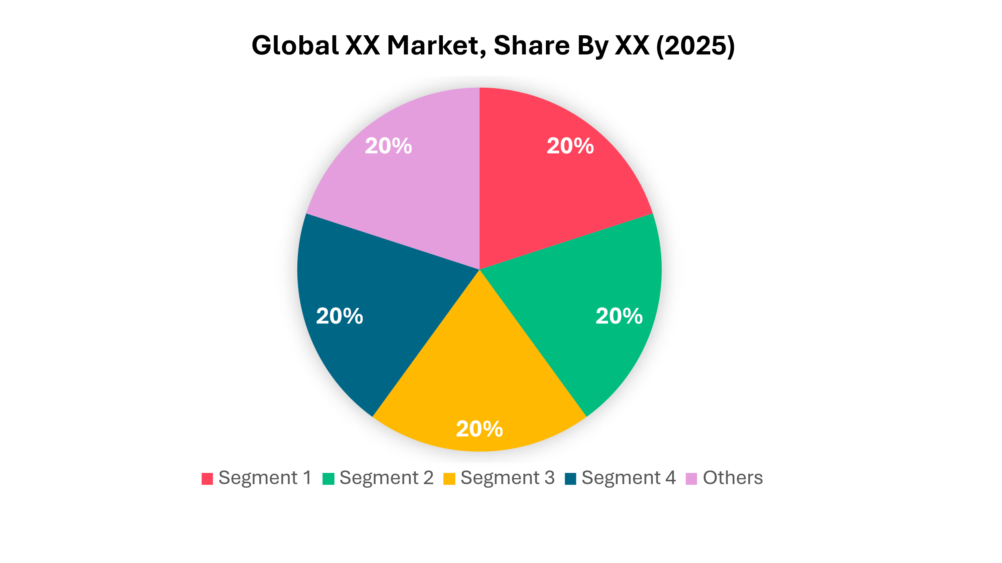

By Segment | 2025
By Dialysis Type | XX
By Product Type | XX
By Technology | XX
By Modality | XX
By Age Group | XX
By Service Type | XX
By Indication | XX
By End User | XX
Others | XX

Hemodialysis and Peritoneal Dialysis Market Segmentations Analysis

By Dialysis Type
Estimated Market Share (2025): XX %
Hemodialysis remains the dominant dialysis type because it is the standard treatment for most ESRD patients and is widely available through established dialysis networks. In-center hemodialysis holds the largest share due to advanced infrastructure, availability of trained professionals, and reimbursement support in major markets such as the U.S., Europe, and Japan. The large installed base of dialysis clinics further strengthens its position.
Peritoneal dialysis is witnessing rapid growth due to the increasing preference for home-based therapies and reduced hospital dependency. APD is expanding faster because automated cycler devices improve convenience, treatment adherence, and patient quality of life. Government initiatives promoting home dialysis and technological advancements are also supporting growth.

By Product Type
Estimated Market Share (2025): XX %
Consumables dominate because they require frequent replacement during every dialysis session, generating recurring demand. Dialyzers account for the largest share due to their essential role in blood purification and increasing adoption of high-performance membranes. Growing dialysis patient populations further boost recurring purchases.
The dialysis equipment segment is growing rapidly due to investments in advanced and connected dialysis technologies. Home dialysis machines are expanding the fastest as healthcare systems encourage decentralized care to reduce costs and improve patient convenience.

By Technology
Estimated Market Share (2025): XX %
Conventional dialysis systems continue to lead because they are well-established, clinically validated, and widely installed across hospitals and dialysis centers worldwide. Their proven safety profile and extensive reimbursement coverage maintain strong market demand.
Wearable and portable dialysis technologies are expected to record the highest growth due to increasing R&D investments and the demand for patient mobility. These systems aim to improve quality of life by reducing dependence on fixed dialysis facilities.

By Modality
Estimated Market Share (2025): XX %
In-center dialysis dominates because it provides continuous medical supervision and access to specialized healthcare professionals. Most ESRD patients continue to receive treatment in dedicated dialysis clinics due to established infrastructure and reimbursement systems.
Home-based dialysis is expanding rapidly due to favorable government policies, telehealth integration, and increasing patient preference for flexible treatment schedules. Cost savings for healthcare systems also encourage wider adoption.

By Age Group
Estimated Market Share (2025): XX %
Adults represent the largest patient group because CKD and ESRD are highly prevalent among middle-aged populations with diabetes and hypertension. Rising chronic disease incidence continues to support this segment's dominance.
The geriatric segment is expected to grow the fastest due to global population aging and increasing rates of kidney disease among elderly individuals. Improved access to renal replacement therapies is further driving growth.

By Service Type
Estimated Market Share (2025): XX %
Chronic dialysis services dominate because ESRD patients require lifelong and regular treatment sessions. The increasing burden of chronic kidney disease ensures stable long-term demand for these services.
Home dialysis support services are expected to record the highest growth due to rising adoption of home therapies, telemedicine platforms, and government initiatives encouraging patient-centered care. Training, maintenance, and remote monitoring services are becoming increasingly important.

By Indication
Estimated Market Share (2025): XX %
ESRD dominates because dialysis is a life-sustaining therapy for patients with permanent kidney failure. The increasing prevalence of diabetes and hypertension globally continues to increase ESRD patient numbers.
AKI is expected to grow at the highest rate due to rising ICU admissions, sepsis cases, and postoperative complications. Improved critical care facilities and early intervention strategies are increasing dialysis use for AKI patients.
By End User
Estimated Market Share (2025): XX %
Dialysis centers lead the market because they provide specialized infrastructure and manage high patient volumes efficiently. The expansion of private dialysis chains and favorable reimbursement frameworks further supports their leadership.
Home care settings are growing rapidly as healthcare systems promote home dialysis to lower treatment costs and improve patient comfort. Advances in portable equipment and remote monitoring technologies are accelerating adoption.
Market Regional Insights:
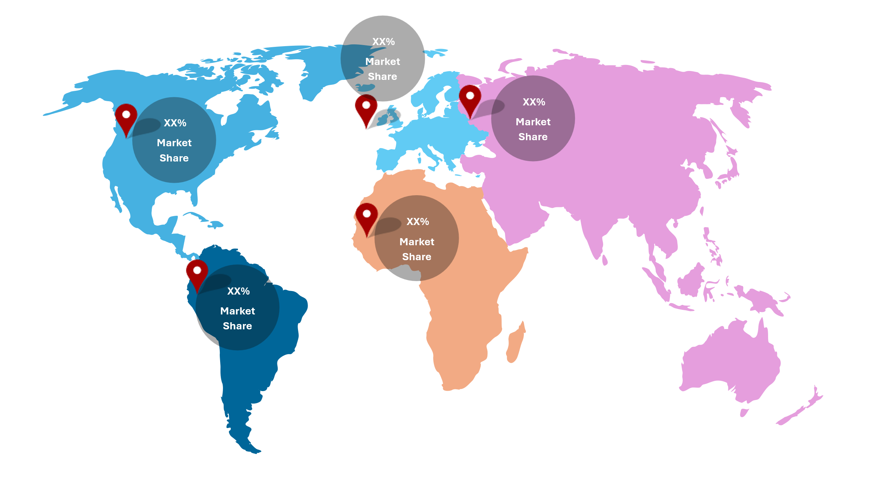
By Geography | 2022 | 2025 | 2032
North America | XX% | XX% | XX%
US | XX% | XX% | XX%
Canada | XX% | XX% | XX%
Europe | XX% | XX% | XX%
Germany | XX% | XX% | XX%
UK | XX% | XX% | XX%
France | XX% | XX% | XX%
Italy | XX% | XX% | XX%
Spain | XX% | XX% | XX%
Switzerland | XX% | XX% | XX%
Netherlands | XX% | XX% | XX%
Rest of Europe | XX% | XX% | XX%
Asia Pacific | XX% | XX% | XX%
China | XX% | XX% | XX%
India | XX% | XX% | XX%
Japan | XX% | XX% | XX%
South Korea | XX% | XX% | XX%
Singapore | XX% | XX% | XX%
Australia | XX% | XX% | XX%
Thailand | XX% | XX% | XX%
Malaysia | XX% | XX% | XX%
Philippines | XX% | XX% | XX%
Indonesia | XX% | XX% | XX%
Rest of Asia Pacific | XX% | XX% | XX%
Middle East & Africa | XX% | XX% | XX%
Saudi Arabia | XX% | XX% | XX%
United Arab Emirates | XX% | XX% | XX%
South Africa | XX% | XX% | XX%
Egypt | XX% | XX% | XX%
Israel | XX% | XX% | XX%
Rest of MEA | XX% | XX% | XX%
Latin America | XX% | XX% | XX%
Brazil | XX% | XX% | XX%
Mexico | XX% | XX% | XX%
Argentina | XX% | XX% | XX%
Chile | XX% | XX% | XX%
Colombia | XX% | XX% | XX%
Peru | XX% | XX% | XX%
Rest of LA | XX% | XX% | XX%

North America Hemodialysis and Peritoneal Dialysis Market Analysis
North America accounted for approximately XX % of the global Hemodialysis and Peritoneal Dialysis Market in 2025, with a market value of around USD XX billion, growing at a CAGR of XX % during 2025–2032, driven by the rising prevalence of chronic kidney disease (CKD), end-stage renal disease (ESRD), and increasing adoption of home dialysis therapies.

Market Intelligence Overview (Historical, Current, Forecast):
• 2025 North America Hemodialysis and Peritoneal Dialysis Market Size: USD XX Billion
• 2035 North America Hemodialysis and Peritoneal Dialysis Market Size: USD XX Billion
• North America Hemodialysis and Peritoneal Dialysis Market CAGR (2026-2035): XX%
Drivers
- Rising prevalence of CKD and ESRD
- Strong reimbursement support for dialysis treatments
- Increasing adoption of home dialysis therapies
- Advanced renal care infrastructure
Restraints
- High dialysis treatment costs
- Shortage of nephrology professionals
- Dialysis-related complications
- Growing healthcare expenditure burden
Opportunities
- Expansion of home-based peritoneal dialysis
- Adoption of remote patient monitoring technologies
- Development of portable dialysis devices
- Increasing investment in renal care innovation

United States Hemodialysis and Peritoneal Dialysis Market Analysis
The U.S. held the largest share of the North American Hemodialysis and Peritoneal Dialysis Market in 2025, with a market value of approximately USD XX billion, growing at a CAGR of XX % during 2025–2032, supported by a large ESRD patient population and favorable reimbursement policies.

Market Intelligence Overview (Historical, Current, Forecast):
• 2025 United States Hemodialysis and Peritoneal Dialysis Market Size: USD XX Billion
• 2035 United States Hemodialysis and Peritoneal Dialysis Market Size: USD XX Billion
• United States Hemodialysis and Peritoneal Dialysis Market CAGR (2026-2035): XX%
Drivers
- Rising incidence of CKD and ESRD
- Strong Medicare support for dialysis services
- Increasing adoption of home dialysis
- Advanced dialysis infrastructure
Restraints
- High long-term treatment costs
- Dialysis-related infection risks
- Workforce shortages
- Patient adherence challenges
Opportunities
- Expansion of home hemodialysis programs
- AI-enabled dialysis monitoring
- Growth in portable dialysis technologies
- Increasing investment in renal care research

Canada Hemodialysis and Peritoneal Dialysis Market Analysis
Canada accounted for approximately XX % of the North American Hemodialysis and Peritoneal Dialysis Market in 2025, with a market value of around USD XX billion, growing at a CAGR of XX % during 2025–2032, driven by rising CKD prevalence and government-supported renal care programs.

Market Intelligence Overview (Historical, Current, Forecast):
• 2025 Canada Hemodialysis and Peritoneal Dialysis Market Size: USD XX Billion
• 2035 Canada Hemodialysis and Peritoneal Dialysis Market Size: USD XX Billion
• Canada Hemodialysis and Peritoneal Dialysis Market CAGR (2026-2035): XX%
Drivers
- Increasing prevalence of kidney disease
- Strong public healthcare coverage
- Growing elderly population
- Expansion of dialysis care services
Restraints
- High treatment and operational costs
- Limited access in remote regions
- Shortage of nephrology specialists
- Long waiting times for renal care
Opportunities
- Expansion of home-based dialysis programs
- Adoption of telehealth for renal care
- Development of advanced dialysis systems
- Increasing government healthcare investments

Europe Hemodialysis and Peritoneal Dialysis Market Analysis
Europe accounted for approximately XX % of the global Hemodialysis and Peritoneal Dialysis Market in 2025, with a market value of around USD XX billion, growing at a CAGR of XX % during 2025–2032, driven by the increasing prevalence of chronic kidney disease, aging populations, and strong healthcare infrastructure.

Market Intelligence Overview (Historical, Current, Forecast):
• 2025 Europe Hemodialysis and Peritoneal Dialysis Market Size: USD XX Billion
• 2035 Europe Hemodialysis and Peritoneal Dialysis Market Size: USD XX Billion
• Europe Hemodialysis and Peritoneal Dialysis Market CAGR (2026-2035): XX%
Drivers
- Rising incidence of CKD and ESRD
- Growing elderly population
- Strong reimbursement systems
- Increasing adoption of home dialysis therapies
Restraints
- High dialysis treatment costs
- Shortage of skilled nephrology professionals
- Dialysis-related complications
- Regulatory and operational challenges
Opportunities
- Expansion of home-based dialysis
- Adoption of portable dialysis technologies
- Integration of digital patient monitoring
- Growth in personalized renal care solutions

Germany Hemodialysis and Peritoneal Dialysis Market Analysis
Germany accounted for approximately XX % of the European Hemodialysis and Peritoneal Dialysis Market in 2025, with a market value of around USD XX billion, growing at a CAGR of XX % during 2025–2032, supported by advanced renal care infrastructure and a large dialysis patient population.

Market Intelligence Overview (Historical, Current, Forecast):
• 2025 Germany Hemodialysis and Peritoneal Dialysis Market Size: USD XX Billion
• 2035 Germany Hemodialysis and Peritoneal Dialysis Market Size: USD XX Billion
• Germany Hemodialysis and Peritoneal Dialysis Market CAGR (2026-2035): XX%
Drivers
- Strong healthcare infrastructure
- Rising CKD prevalence
- Advanced dialysis technologies
- Comprehensive reimbursement coverage
Restraints
- High healthcare expenditure
- Workforce shortages
- Dialysis-related hospitalization risks
- Regulatory compliance costs
Opportunities
- Expansion of home dialysis programs
- AI-enabled dialysis management
- Portable dialysis devices
- Digital healthcare integration

United Kingdom Hemodialysis and Peritoneal Dialysis Market Analysis
The UK accounted for approximately XX % of the European Hemodialysis and Peritoneal Dialysis Market in 2025, with a market value of around USD XX billion, growing at a CAGR of XX % during 2025–2032, driven by increasing kidney disease prevalence and NHS-supported renal care services.

Market Intelligence Overview (Historical, Current, Forecast):
• 2025 United Kingdom Hemodialysis and Peritoneal Dialysis Market Size: USD XX Billion
• 2035 United Kingdom Hemodialysis and Peritoneal Dialysis Market Size: USD XX Billion
• United Kingdom Hemodialysis and Peritoneal Dialysis Market CAGR (2026-2035): XX%
Drivers
- Growing CKD patient population
- Strong NHS dialysis support
- Rising elderly population
- Increasing home dialysis adoption
Restraints
- Capacity constraints in dialysis centers
- Workforce shortages
- Rising treatment costs
- Long waiting periods for specialist care
Opportunities
- Home hemodialysis expansion
- Remote patient monitoring
- Smart dialysis technologies
- Growth in renal care innovation

France Hemodialysis and Peritoneal Dialysis Market Analysis
France accounted for approximately XX % of the European Hemodialysis and Peritoneal Dialysis Market in 2025, with a market value of around USD XX billion, growing at a CAGR of XX % during 2025–2032, supported by favorable reimbursement policies and increasing demand for renal replacement therapies.

Market Intelligence Overview (Historical, Current, Forecast):
• 2025 France Hemodialysis and Peritoneal Dialysis Market Size: USD XX Billion
• 2035 France Hemodialysis and Peritoneal Dialysis Market Size: USD XX Billion
• France Hemodialysis and Peritoneal Dialysis Market CAGR (2026-2035): XX%
Drivers
- Rising kidney disease burden
- Strong healthcare coverage
- Growing elderly population
- Expansion of dialysis services
Restraints
- High treatment costs
- Skilled workforce shortages
- Dialysis-related complications
- Healthcare budget pressures
Opportunities
- Growth in home-based dialysis
- AI-powered patient monitoring
- Advanced dialysis technologies
- Expansion of outpatient renal care

Italy Hemodialysis and Peritoneal Dialysis Market Analysis
Italy accounted for approximately XX % of the European Hemodialysis and Peritoneal Dialysis Market in 2025, with a market value of around USD XX billion, growing at a CAGR of XX % during 2025–2032, driven by increasing diabetes prevalence and an aging population.

Market Intelligence Overview (Historical, Current, Forecast):
• 2025 Italy Hemodialysis and Peritoneal Dialysis Market Size: USD XX Billion
• 2035 Italy Hemodialysis and Peritoneal Dialysis Market Size: USD XX Billion
• Italy Hemodialysis and Peritoneal Dialysis Market CAGR (2026-2035): XX%
Drivers
- Rising diabetes cases
- Growing elderly population
- Increasing demand for dialysis services
- Government-supported healthcare programs
Restraints
- High dialysis treatment costs
- Regional healthcare disparities
- Workforce shortages
- Infrastructure limitations
Opportunities
- Home dialysis expansion
- Adoption of portable dialysis systems
- Telehealth integration
- Growth in renal care investments

Spain Hemodialysis and Peritoneal Dialysis Market Analysis
Spain accounted for approximately XX % of the European Hemodialysis and Peritoneal Dialysis Market in 2025, with a market value of around USD XX billion, growing at a CAGR of XX % during 2025–2032, supported by improving renal disease management and expanding healthcare services.

Market Intelligence Overview (Historical, Current, Forecast):
• 2025 Spain Hemodialysis and Peritoneal Dialysis Market Size: USD XX Billion
• 2035 Spain Hemodialysis and Peritoneal Dialysis Market: USD XX Billion
• Spain Hemodialysis and Peritoneal Dialysis Market CAGR (2026-2035): XX%
Drivers
- Rising CKD prevalence
- Growing healthcare expenditure
- Expansion of dialysis facilities
- Increasing elderly population
Restraints
- High operational costs
- Limited specialist availability
- Dialysis-related complications
- Healthcare budget constraints
Opportunities
- Home-based dialysis adoption
- Smart dialysis technologies
- Remote patient monitoring
- Expansion of renal care programs

Switzerland Hemodialysis and Peritoneal Dialysis Market Analysis
Switzerland accounted for approximately XX % of the European Hemodialysis and Peritoneal Dialysis Market in 2025, with a market value of around USD XX billion, growing at a CAGR of XX % during 2025–2032, driven by advanced healthcare infrastructure and high-quality renal care services.

Market Intelligence Overview (Historical, Current, Forecast):
• 2025 Switzerland Hemodialysis and Peritoneal Dialysis Market Size: USD XX Billion
• 2035 Switzerland Hemodialysis and Peritoneal Dialysis Market Size: USD XX Billion
• Switzerland Hemodialysis and Peritoneal Dialysis Market CAGR (2026-2035): XX%
Drivers
- Advanced healthcare system
- High healthcare spending
- Strong dialysis infrastructure
- Growing elderly population
Restraints
- High treatment costs
- Workforce shortages
- Limited patient pool
- Regulatory requirements
Opportunities
- Premium dialysis technologies
- Home dialysis expansion
- AI-assisted renal care
- Personalized treatment solutions

Netherlands Hemodialysis and Peritoneal Dialysis Market Analysis
The Netherlands accounted for approximately XX % of the European Hemodialysis and Peritoneal Dialysis Market in 2025, with a market value of around USD XX billion, growing at a CAGR of XX% during 2025–2032, supported by increasing adoption of home dialysis and digital healthcare technologies.

Market Intelligence Overview (Historical, Current, Forecast):
• 2025 Netherlands Hemodialysis and Peritoneal Dialysis Market Size: USD XX Billion
• 2035 Netherlands Hemodialysis and Peritoneal Dialysis Market Size: USD XX Billion
• Netherlands Hemodialysis and Peritoneal Dialysis Market CAGR (2026-2035): XX%
Drivers
- Strong healthcare infrastructure
- Growing home dialysis adoption
- Rising CKD prevalence
- Digital healthcare integration
Restraints
- High treatment expenses
- Skilled workforce shortages
- Operational challenges
- Reimbursement pressures
Opportunities
- Expansion of home dialysis programs
- Smart monitoring solutions
- Portable dialysis technologies
- Telehealth-based renal care

Rest of Europe Hemodialysis and Peritoneal Dialysis Market Analysis
The Rest of Europe accounted for approximately XX % of the European Hemodialysis and Peritoneal Dialysis Market in 2025, with a market value of around USD XX billion, growing at a CAGR of XX % during 2025–2032, driven by expanding dialysis infrastructure and improving access to renal care services.

Market Intelligence Overview (Historical, Current, Forecast):
• 2025 Rest of Europe Hemodialysis and Peritoneal Dialysis Market Size: USD XX Billion
• 2035 Rest of Europe Hemodialysis and Peritoneal Dialysis Market Size: USD XX Billion
• Rest of Europe Hemodialysis and Peritoneal Dialysis Market CAGR (2026-2035): XX%
Drivers
- Increasing CKD prevalence
- Expanding healthcare infrastructure
- Growing elderly population
- Rising awareness of kidney disease
Restraints
- Cost pressures on healthcare systems
- Workforce shortages
- Unequal access to renal care
- Infrastructure limitations
Opportunities
- Expansion of dialysis centers
- Home dialysis adoption
- Digital healthcare solutions
- Advanced renal care technologies

Asia Pacific Hemodialysis and Peritoneal Dialysis Market Analysis
Asia Pacific accounted for approximately XX% of the global Hemodialysis and Peritoneal Dialysis Market in 2025, with a market value of around USD XX billion, growing at a CAGR of XX% during 2025–2032, driven by the rising prevalence of chronic kidney disease, increasing diabetes burden, and expanding access to dialysis services.

Market Intelligence Overview (Historical, Current, Forecast):
• 2025 Asia Pacific Hemodialysis and Peritoneal Dialysis Market Size: USD XX Billion
• 2035 Asia Pacific Hemodialysis and Peritoneal Dialysis Market Size: USD XX Billion
• Asia Pacific Hemodialysis and Peritoneal Dialysis Market CAGR (2026-2035): XX%
Drivers
- Rising CKD and ESRD prevalence
- Growing diabetic population
- Expanding healthcare infrastructure
- Increasing government support for renal care
Restraints
- High dialysis treatment costs
- Limited access in rural areas
- Shortage of nephrologists
- Low awareness of kidney disease
Opportunities
- Expansion of home dialysis therapies
- Growing adoption of portable dialysis systems
- Increasing healthcare investments
- Development of smart dialysis technologies

China Hemodialysis and Peritoneal Dialysis Market Analysis
China accounted for approximately XX % of the Asia Pacific Hemodialysis and Peritoneal Dialysis Market in 2025, with a market value of around USD XX billion, growing at a CAGR of XX% during 2025–2032, driven by a large ESRD patient population and increasing healthcare expenditure.

Market Intelligence Overview (Historical, Current, Forecast):
• 2025 China Hemodialysis and Peritoneal Dialysis Market Size: USD XX Billion
• 2035 China Hemodialysis and Peritoneal Dialysis Market Size: USD XX Billion
• China Hemodialysis and Peritoneal Dialysis Market CAGR (2026-2035): XX%
Drivers
- Growing CKD prevalence
- Rising diabetes incidence
- Expanding dialysis infrastructure
- Government healthcare reforms
Restraints
- Urban-rural healthcare disparities
- High treatment costs
- Workforce shortages
- Limited awareness in remote areas
Opportunities
- Expansion of peritoneal dialysis programs
- Smart dialysis technologies
- Home-based dialysis adoption
- Increasing healthcare investments

India Hemodialysis and Peritoneal Dialysis Market Analysis
India accounted for approximately XX % of the Asia Pacific Hemodialysis and Peritoneal Dialysis Market in 2025, with a market value of around USD XX billion, growing at a CAGR of XX % during 2025–2032, supported by government dialysis programs and increasing healthcare access.

Market Intelligence Overview (Historical, Current, Forecast):
• 2025 India Hemodialysis and Peritoneal Dialysis Market Size: USD XX Billion
• 2035 India Hemodialysis and Peritoneal Dialysis Market Size: USD XX Billion
• India Hemodialysis and Peritoneal Dialysis Market CAGR (2026-2035): XX%
Drivers
- Rising CKD and diabetes prevalence
- Government dialysis initiatives
- Expanding healthcare infrastructure
- Increasing patient awareness
Restraints
- High out-of-pocket treatment costs
- Limited dialysis access in rural regions
- Shortage of nephrology specialists
- Low insurance penetration
Opportunities
- Growth in public-private partnerships
- Expansion of home dialysis
- Development of affordable dialysis solutions
- Rising investments in renal care

Japan Hemodialysis and Peritoneal Dialysis Market Analysis
Japan accounted for approximately XX % of the Asia Pacific Hemodialysis and Peritoneal Dialysis Market in 2025, with a market value of around USD XX billion, growing at a CAGR of XX % during 2025–2032, driven by one of the world's largest dialysis patient populations.

Market Intelligence Overview (Historical, Current, Forecast):
• 2025 Japan Hemodialysis and Peritoneal Dialysis Market Size: USD XX Billion
• 2035 Japan Hemodialysis and Peritoneal Dialysis Market Size: USD XX Billion
• Japan Hemodialysis and Peritoneal Dialysis Market CAGR (2026-2035): XX%
Drivers
- Large dialysis patient base
- Advanced healthcare infrastructure
- Strong reimbursement support
- Growing elderly population
Restraints
- High treatment costs
- Aging healthcare workforce
- Operational challenges
- Healthcare expenditure pressures
Opportunities
- Home dialysis adoption
- AI-enabled dialysis monitoring
- Portable dialysis technologies
- Smart renal care solutions

South Korea Hemodialysis and Peritoneal Dialysis Market Analysis
South Korea accounted for approximately XX % of the Asia Pacific Hemodialysis and Peritoneal Dialysis Market in 2025, with a market value of around USD XX billion, growing at a CAGR of XX% during 2025–2032, supported by healthcare modernization and increasing kidney disease prevalence.

Market Intelligence Overview (Historical, Current, Forecast):
• 2025 South Korea Hemodialysis and Peritoneal Dialysis Market Size: USD XX Billion
• 2035 South Korea Hemodialysis and Peritoneal Dialysis Market Size: USD XX Billion
• South Korea Hemodialysis and Peritoneal Dialysis Market CAGR (2026-2035): XX%
Drivers
- Rising CKD burden
- Advanced healthcare infrastructure
- Strong government support
- Growing elderly population
Restraints
- High treatment costs
- Workforce shortages
- Dialysis-related complications
- Capacity limitations
Opportunities
- Home dialysis expansion
- Digital healthcare integration
- AI-powered monitoring solutions
- Advanced dialysis equipment

Singapore Hemodialysis and Peritoneal Dialysis Market Analysis
Singapore accounted for approximately XX % of the Asia Pacific Hemodialysis and Peritoneal Dialysis Market in 2025, with a market value of around USD XX billion, growing at a CAGR of XX % during 2025–2032, driven by advanced healthcare services and increasing chronic disease prevalence.

Market Intelligence Overview (Historical, Current, Forecast):
• 2025 Singapore Hemodialysis and Peritoneal Dialysis Market Size: USD XX Billion
• 2035 Singapore Hemodialysis and Peritoneal Dialysis Market Size: USD XX Billion
• Singapore Hemodialysis and Peritoneal Dialysis Market CAGR (2026-2035): XX%
Drivers
- Advanced healthcare infrastructure
- Rising kidney disease burden
- Government healthcare support
- High healthcare spending
Restraints
- High treatment costs
- Limited patient pool
- Workforce challenges
- Import dependency
Opportunities
- Smart dialysis technologies
- Home dialysis adoption
- AI-enabled renal care
- Expansion of specialty care services

Australia Hemodialysis and Peritoneal Dialysis Market Analysis
Australia accounted for approximately XX% of the Asia Pacific Hemodialysis and Peritoneal Dialysis Market in 2025, with a market value of around USD XX billion, growing at a CAGR of XX % during 2025–2032, supported by strong renal care programs and government healthcare funding.

Market Intelligence Overview (Historical, Current, Forecast):
• 2025 Australia Hemodialysis and Peritoneal Dialysis Market Size: USD XX Billion
• 2035 Australia Hemodialysis and Peritoneal Dialysis Market Size: USD XX Billion
• Australia Hemodialysis and Peritoneal Dialysis Market CAGR (2026-2035): XX%
Drivers
- Rising CKD prevalence
- Government-funded dialysis programs
- Growing elderly population
- Strong healthcare infrastructure
Restraints
- High treatment costs
- Rural accessibility challenges
- Workforce shortages
- Operational expenses
Opportunities
- Home dialysis growth
- Telehealth integration
- Portable dialysis systems
- Digital patient monitoring

Thailand Hemodialysis and Peritoneal Dialysis Market Analysis
Thailand accounted for approximately XX % of the Asia Pacific Hemodialysis and Peritoneal Dialysis Market in 2025, with a market value of around USD XX billion, growing at a CAGR of XX % during 2025–2032.

Market Intelligence Overview (Historical, Current, Forecast):
• 2025 Thailand Hemodialysis and Peritoneal Dialysis Market Size: USD XX Billion
• 2035 Thailand Hemodialysis and Peritoneal Dialysis Market Size: USD XX Billion
• Thailand Hemodialysis and Peritoneal Dialysis Market CAGR (2026-2035): XX%
Drivers
- Rising diabetes prevalence
- Expanding healthcare coverage
- Increasing dialysis access
- Government support programs
Restraints
- High treatment costs
- Limited specialist availability
- Rural healthcare disparities
- Infrastructure limitations
Opportunities
- Peritoneal dialysis expansion
- Affordable dialysis solutions
- Healthcare infrastructure development
- Smart dialysis systems

Malaysia Hemodialysis and Peritoneal Dialysis Market Analysis
Malaysia accounted for approximately XX % of the Asia Pacific Hemodialysis and Peritoneal Dialysis Market in 2025, with a market value of around USD XX billion, growing at a CAGR of XX % during 2025–2032.

Market Intelligence Overview (Historical, Current, Forecast):
• 2025 Malaysia Hemodialysis and Peritoneal Dialysis Market Size: USD XX Billion
• 2035 Malaysia Hemodialysis and Peritoneal Dialysis Market Size: USD XX Billion
• Malaysia Hemodialysis and Peritoneal Dialysis Market CAGR (2026-2035): XX%
Drivers
- Rising CKD burden
- Expanding dialysis centers
- Government healthcare support
- Growing awareness
Restraints
- High treatment expenses
- Workforce shortages
- Urban-rural access gap
- Capacity constraints
Opportunities
- Home dialysis adoption
- Smart monitoring technologies
- Expansion of renal care services
- Public-private partnerships

Philippines Hemodialysis and Peritoneal Dialysis Market Analysis
The Philippines accounted for approximately XX % of the Asia Pacific Hemodialysis and Peritoneal Dialysis Market in 2025, with a market value of around USD XX billion, growing at a CAGR of XX % during 2025–2032.

Market Intelligence Overview (Historical, Current, Forecast):
• 2025 Philippines Hemodialysis and Peritoneal Dialysis Market Size: USD XX Billion
• 2035 Philippines Hemodialysis and Peritoneal Dialysis Market Size: USD XX Billion
• Philippines Hemodialysis and Peritoneal Dialysis Market CAGR (2026-2035): XX%
Drivers
- Rising chronic kidney disease prevalence
- Expanding healthcare coverage
- Increasing dialysis awareness
- Growing healthcare investments
Restraints
- Affordability challenges
- Limited dialysis infrastructure
- Workforce shortages
- Regional disparities
Opportunities
- Expansion of dialysis centers
- Home dialysis growth
- Affordable treatment options
- Digital healthcare solutions

Indonesia Hemodialysis and Peritoneal Dialysis Market Analysis
Indonesia accounted for approximately XX% of the Asia Pacific Hemodialysis and Peritoneal Dialysis Market in 2025, with a market value of around USD XX billion, growing at a CAGR of XX % during 2025–2032.

Market Intelligence Overview (Historical, Current, Forecast):
• 2025 Indonesia Hemodialysis and Peritoneal Dialysis Market Size: USD XX Billion
• 2035 Indonesia Hemodialysis and Peritoneal Dialysis Market Size: USD XX Billion
• Indonesia Hemodialysis and Peritoneal Dialysis Market CAGR (2026-2035): XX%
Drivers
- Large CKD patient population
- Expanding healthcare infrastructure
- Government health initiatives
- Rising diabetes prevalence
Restraints
- Geographic accessibility challenges
- High treatment costs
- Limited specialist availability
- Infrastructure gaps
Opportunities
- Home dialysis expansion
- Portable dialysis systems
- Increased healthcare investments
- Smart renal care technologies

Rest of Asia Pacific Hemodialysis and Peritoneal Dialysis Market Analysis
The Rest of Asia Pacific accounted for approximately XX % of the Asia Pacific Hemodialysis and Peritoneal Dialysis Market in 2025, with a market value of around USD XX billion, growing at a CAGR of XX % during 2025–2032.

Market Intelligence Overview (Historical, Current, Forecast):
• 2025 Rest of Asia Pacific Hemodialysis and Peritoneal Dialysis Market Size: USD XX Billion
• 2035 Rest of Asia Pacific Hemodialysis and Peritoneal Dialysis Market Size: USD XX Billion
• Rest of Asia Pacific Hemodialysis and Peritoneal Dialysis Market CAGR (2026-2035): XX%
Drivers
- Rising kidney disease burden
- Expanding healthcare infrastructure
- Growing dialysis awareness
- Increasing government support
Restraints
- High treatment costs
- Workforce shortages
- Limited access to specialized care
- Infrastructure limitations
Opportunities
- Expansion of dialysis centers
- Home dialysis adoption
- Digital health integration
- Advanced dialysis technologies

Middle East & Africa Hemodialysis and Peritoneal Dialysis Market Analysis
Middle East & Africa accounted for approximately XX % of the global Hemodialysis and Peritoneal Dialysis Market in 2025, with a market value of around USD XX billion, growing at a CAGR of XX % during 2025–2032, driven by the rising prevalence of chronic kidney disease, diabetes, and expanding dialysis infrastructure.

Market Intelligence Overview (Historical, Current, Forecast):
• 2025 Middle East & Africa Hemodialysis and Peritoneal Dialysis Market Size: USD XX Billion
• 2035 Middle East & Africa Hemodialysis and Peritoneal Dialysis Market Size: USD XX Billion
• Middle East & Africa Hemodialysis and Peritoneal Dialysis Market CAGR (2026-2035): XX%
Drivers
- Increasing CKD and ESRD prevalence
- Rising diabetes and hypertension burden
- Expanding dialysis centers
- Growing healthcare investments
Restraints
- High dialysis treatment costs
- Limited access to specialized renal care
- Workforce shortages
- Infrastructure constraints
Opportunities
- Expansion of home-based dialysis
- Public-private healthcare partnerships
- Advanced dialysis technologies
- Growth in renal care investments

Saudi Arabia Hemodialysis and Peritoneal Dialysis Market Analysis
Saudi Arabia accounted for approximately XX % of the Middle East & Africa Hemodialysis and Peritoneal Dialysis Market in 2025, with a market value of around USD XX billion, growing at a CAGR of XX % during 2025–2032, supported by increasing healthcare expenditure and rising kidney disease prevalence.

Market Intelligence Overview (Historical, Current, Forecast):
• 2025 Saudi Arabia Hemodialysis and Peritoneal Dialysis Market Size: USD XX Billion
• 2035 Saudi Arabia Hemodialysis and Peritoneal Dialysis Market Size: USD XX Billion
• Saudi Arabia Hemodialysis and Peritoneal Dialysis Market CAGR (2026-2035): XX%
Drivers
- Rising CKD and diabetes prevalence
- Vision 2030 healthcare initiatives
- Expanding dialysis infrastructure
- Government healthcare funding
Restraints
- High treatment costs
- Dependence on imported equipment
- Workforce shortages
- Dialysis-related complications
Opportunities
- Home dialysis expansion
- Smart dialysis technologies
- Digital patient monitoring
- Growth in private renal care services

United Arab Emirates Hemodialysis and Peritoneal Dialysis Market Analysis
The UAE accounted for approximately XX % of the Middle East & Africa Hemodialysis and Peritoneal Dialysis Market in 2025, with a market value of around USD XX billion, growing at a CAGR of XX % during 2025–2032, driven by advanced healthcare infrastructure and increasing demand for renal replacement therapies.

Market Intelligence Overview (Historical, Current, Forecast):
• 2025 United Arab Emirates Hemodialysis and Peritoneal Dialysis Market Size: USD XX Billion
• 2035 United Arab Emirates Hemodialysis and Peritoneal Dialysis Market Size: USD XX Billion
• United Arab Emirates Hemodialysis and Peritoneal Dialysis Market CAGR (2026-2035): XX%
Drivers
- Advanced healthcare facilities
- Rising chronic disease burden
- Government healthcare investments
- Increasing dialysis awareness
Restraints
- High operational costs
- Skilled workforce shortages
- Import dependency
- Treatment affordability concerns
Opportunities
- AI-enabled dialysis monitoring
- Expansion of home dialysis
- Advanced renal care centers
- Smart dialysis equipment adoption

South Africa Hemodialysis and Peritoneal Dialysis Market Analysis
South Africa accounted for approximately XX % of the Middle East & Africa Hemodialysis and Peritoneal Dialysis Market in 2025, with a market value of around USD XX billion, growing at a CAGR of XX % during 2025–2032, driven by increasing CKD prevalence and expanding renal care services.

Market Intelligence Overview (Historical, Current, Forecast):
• 2025 South Africa Hemodialysis and Peritoneal Dialysis Market Size: USD XX Billion
• 2035 South Africa Hemodialysis and Peritoneal Dialysis Market Size: USD XX Billion
• South Africa Hemodialysis and Peritoneal Dialysis Market CAGR (2026-2035): XX%
Drivers
- Rising CKD and ESRD cases
- Expanding dialysis centers
- Government healthcare initiatives
- Increasing healthcare awareness
Restraints
- High dialysis treatment costs
- Limited access in rural areas
- Workforce shortages
- Healthcare infrastructure challenges
Opportunities
- Expansion of home dialysis
- Growth in private dialysis centers
- Renal care infrastructure investments
- Adoption of advanced dialysis technologies

Egypt Hemodialysis and Peritoneal Dialysis Market Analysis
Egypt accounted for approximately XX% of the Middle East & Africa Hemodialysis and Peritoneal Dialysis Market in 2025, with a market value of around USD XX billion, growing at a CAGR of XX % during 2025–2032, supported by increasing healthcare access and rising kidney disease prevalence.

Market Intelligence Overview (Historical, Current, Forecast):
• 2025 Egypt Hemodialysis and Peritoneal Dialysis Market Size: USD XX Billion
• 2035 Egypt Hemodialysis and Peritoneal Dialysis Market Size: USD XX Billion
• Egypt Hemodialysis and Peritoneal Dialysis Market CAGR (2026-2035): XX%
Drivers
- Growing CKD burden
- Expanding healthcare coverage
- Rising diabetes prevalence
- Government healthcare programs
Restraints
- High treatment expenses
- Limited specialist availability
- Infrastructure gaps
- Urban-rural disparities
Opportunities
- Expansion of dialysis infrastructure
- Affordable treatment solutions
- Home dialysis programs
- Public-private healthcare partnerships

Israel Hemodialysis and Peritoneal Dialysis Market Analysis
Israel accounted for approximately XX % of the Middle East & Africa Hemodialysis and Peritoneal Dialysis Market in 2025, with a market value of around USD XX billion, growing at a CAGR of XX % during 2025–2032, driven by advanced healthcare services and strong adoption of innovative dialysis technologies.

Market Intelligence Overview (Historical, Current, Forecast):
• 2025 Israel Hemodialysis and Peritoneal Dialysis Market Size: USD XX Billion
• 2035 Israel Hemodialysis and Peritoneal Dialysis Market Size: USD XX Billion
• Israel Hemodialysis and Peritoneal Dialysis Market CAGR (2026-2035): XX%
Drivers
- Advanced healthcare infrastructure
- High-quality renal care services
- Strong reimbursement support
- Increasing elderly population
Restraints
- High healthcare costs
- Workforce shortages
- Limited patient population
- Regulatory requirements
Opportunities
- AI-powered dialysis solutions
- Home dialysis expansion
- Smart monitoring technologies
- Personalized renal care

Rest of MEA Hemodialysis and Peritoneal Dialysis Market Analysis
The Rest of MEA accounted for approximately XX % of the Middle East & Africa Hemodialysis and Peritoneal Dialysis Market in 2025, with a market value of around USD XX billion, growing at a CAGR of XX % during 2025–2032.

Market Intelligence Overview (Historical, Current, Forecast):
• 2025 Rest of MEA Hemodialysis and Peritoneal Dialysis Market Size: USD XX Billion
• 2035 Rest of MEA Hemodialysis and Peritoneal Dialysis Market Size: USD XX Billion
• Rest of MEA Hemodialysis and Peritoneal Dialysis Market CAGR (2026-2035): XX%
Drivers
- Growing kidney disease prevalence
- Expanding healthcare infrastructure
- Increasing healthcare investments
- Rising awareness of renal disorders
Restraints
- Limited access to dialysis services
- High treatment costs
- Workforce shortages
- Infrastructure limitations
Opportunities
- Expansion of dialysis centers
- Home-based dialysis adoption
- Digital healthcare integration
- Advanced renal care technologies

Latin America Hemodialysis and Peritoneal Dialysis Market Analysis
Latin America accounted for approximately XX % of the global Hemodialysis and Peritoneal Dialysis Market in 2025, with a market value of around USD XX billion, growing at a CAGR of XX % during 2025–2032, driven by rising CKD prevalence and improving access to renal replacement therapies.

Market Intelligence Overview (Historical, Current, Forecast):
• 2025 Latin America Hemodialysis and Peritoneal Dialysis Market Size: USD XX Billion
• 2035 Latin America Hemodialysis and Peritoneal Dialysis Market Size: USD XX Billion
• Latin America Hemodialysis and Peritoneal Dialysis Market CAGR (2026-2035): XX%
Drivers
- Increasing CKD and ESRD burden
- Growing healthcare expenditure
- Expansion of dialysis services
- Rising awareness of kidney disease
Restraints
- High treatment costs
- Unequal healthcare access
- Workforce shortages
- Limited reimbursement coverage
Opportunities
- Expansion of home dialysis programs
- Investment in dialysis infrastructure
- Adoption of portable dialysis devices
- Growth in private renal care services

Brazil Hemodialysis and Peritoneal Dialysis Market Analysis
Brazil accounted for approximately XX % of the Latin America Hemodialysis and Peritoneal Dialysis Market in 2025, with a market value of around USD XX billion, growing at a CAGR of XX % during 2025–2032, driven by rising chronic kidney disease prevalence and expanding access to dialysis treatment.

Market Intelligence Overview (Historical, Current, Forecast):
• 2025 Brazil Hemodialysis and Peritoneal Dialysis Market Size: USD XX Billion
• 2035 Brazil Hemodialysis and Peritoneal Dialysis Market Size: USD XX Billion
• Brazil Hemodialysis and Peritoneal Dialysis Market CAGR (2026-2035): XX%
Drivers
- Growing CKD and ESRD patient population
- Expansion of public dialysis programs
- Increasing healthcare expenditure
- Rising elderly population
Restraints
- High dialysis treatment costs
- Regional disparities in healthcare access
- Capacity constraints in dialysis centers
- Workforce shortages
Opportunities
- Expansion of home dialysis therapies
- Growth in private renal care services
- Investment in dialysis infrastructure
- Adoption of advanced dialysis technologies

Mexico Hemodialysis and Peritoneal Dialysis Market Analysis
Mexico accounted for approximately XX % of the Latin America Hemodialysis and Peritoneal Dialysis Market in 2025, with a market value of around USD XX billion, growing at a CAGR of XX % during 2025–2032, supported by increasing kidney disease prevalence and healthcare modernization initiatives.

Market Intelligence Overview (Historical, Current, Forecast):
• 2025 Mexico Hemodialysis and Peritoneal Dialysis Market Size: USD XX Billion
• 2035 Mexico Hemodialysis and Peritoneal Dialysis Market Size: USD XX Billion
• Mexico Hemodialysis and Peritoneal Dialysis Market CAGR (2026-2035): XX%
Drivers
- Rising diabetes-related kidney disease
- Growing dialysis patient population
- Expansion of healthcare services
- Increasing awareness of renal disorders
Restraints
- High treatment expenses
- Limited specialist availability
- Uneven healthcare access
- Infrastructure limitations
Opportunities
- Home dialysis adoption
- Expansion of dialysis networks
- Digital healthcare integration
- Growth in private healthcare investments

Argentina Hemodialysis and Peritoneal Dialysis Market Analysis
Argentina accounted for approximately XX % of the Latin America Hemodialysis and Peritoneal Dialysis Market in 2025, with a market value of around USD XX billion, growing at a CAGR of XX % during 2025–2032, driven by increasing demand for renal replacement therapies.

Market Intelligence Overview (Historical, Current, Forecast):
• 2025 Argentina Hemodialysis and Peritoneal Dialysis Market Size: USD XX Billion
• 2035 Argentina Hemodialysis and Peritoneal Dialysis Market Size: USD XX Billion
• Argentina Hemodialysis and Peritoneal Dialysis Market CAGR (2026-2035): XX%
Drivers
- Growing CKD prevalence
- Increasing elderly population
- Expansion of dialysis services
- Rising healthcare awareness
Restraints
- Economic instability
- High equipment and treatment costs
- Workforce shortages
- Healthcare funding challenges
Opportunities
- Expansion of home dialysis programs
- Investment in renal care infrastructure
- Advanced dialysis technologies
- Public-private healthcare partnerships

Chile Hemodialysis and Peritoneal Dialysis Market Analysis
Chile accounted for approximately XX % of the Latin America Hemodialysis and Peritoneal Dialysis Market in 2025, with a market value of around USD XX billion, growing at a CAGR of XX % during 2025–2032, supported by healthcare modernization and increasing dialysis access.

Market Intelligence Overview (Historical, Current, Forecast):
• 2025 Chile Hemodialysis and Peritoneal Dialysis Market Size: USD XX Billion
• 2035 Chile Hemodialysis and Peritoneal Dialysis Market Size: USD XX Billion
• Chile Hemodialysis and Peritoneal Dialysis Market CAGR (2026-2035): XX%
Drivers
- Rising CKD burden
- Strong healthcare infrastructure
- Increasing dialysis awareness
- Government healthcare support
Restraints
- High treatment costs
- Limited specialist workforce
- Operational challenges
- Infrastructure constraints
Opportunities
- Home dialysis expansion
- Smart dialysis technologies
- Telehealth integration
- Growth in renal care investments

Colombia Hemodialysis and Peritoneal Dialysis Market Analysis
Colombia accounted for approximately XX % of the Latin America Hemodialysis and Peritoneal Dialysis Market in 2025, with a market value of around USD XX billion, growing at a CAGR of XX % during 2025–2032, driven by improving access to renal healthcare services.

Market Intelligence Overview (Historical, Current, Forecast):
• 2025 Colombia Hemodialysis and Peritoneal Dialysis Market Size: USD XX Billion
• 2035 Colombia Hemodialysis and Peritoneal Dialysis Market Size: USD XX Billion
• Colombia Hemodialysis and Peritoneal Dialysis Market CAGR (2026-2035): XX%
Drivers
- Growing CKD prevalence
- Expansion of healthcare coverage
- Rising dialysis demand
- Government healthcare reforms
Restraints
- High treatment expenses
- Workforce shortages
- Infrastructure limitations
- Regional healthcare disparities
Opportunities
- Expansion of dialysis centers
- Home-based dialysis therapies
- Advanced patient monitoring solutions
- Growth in private renal care services

Peru Hemodialysis and Peritoneal Dialysis Market Analysis
Peru accounted for approximately XX % of the Latin America Hemodialysis and Peritoneal Dialysis Market in 2025, with a market value of around USD XX billion, growing at a CAGR of XX % during 2025–2032, driven by increasing healthcare investments and growing awareness of kidney disease.

Market Intelligence Overview (Historical, Current, Forecast):
• 2025 Peru Hemodialysis and Peritoneal Dialysis Market Size: USD XX Billion
• 2035 Peru Hemodialysis and Peritoneal Dialysis Market Size: USD XX Billion
• Peru Hemodialysis and Peritoneal Dialysis Market CAGR (2026-2035): XX%
Drivers
- Rising kidney disease burden
- Expansion of healthcare infrastructure
- Increasing patient awareness
- Government healthcare initiatives
Restraints
- Limited access to specialized care
- High treatment costs
- Workforce shortages
- Infrastructure gaps
Opportunities
- Expansion of dialysis facilities
- Affordable treatment programs
- Home dialysis adoption
- Public-private healthcare partnerships

Rest of Latin America Hemodialysis and Peritoneal Dialysis Market Analysis
The Rest of Latin America accounted for approximately XX % of the Latin America Hemodialysis and Peritoneal Dialysis Market in 2025, with a market value of around USD XX billion, growing at a CAGR of XX % during 2025–2032, driven by improving healthcare infrastructure and increasing demand for renal replacement therapies.

Market Intelligence Overview (Historical, Current, Forecast):
• 2025 Rest of Latin America Hemodialysis and Peritoneal Dialysis Market Size: USD XX Billion
• 2035 Rest of Latin America Hemodialysis and Peritoneal Dialysis Market Size: USD XX Billion
• Rest of Latin America Hemodialysis and Peritoneal Dialysis Market CAGR (2026-2035): XX%
Drivers
- Rising prevalence of CKD and ESRD
- Expanding healthcare services
- Growing awareness of kidney health
- Increasing healthcare investments
Restraints
- High treatment costs
- Limited reimbursement coverage
- Workforce shortages
- Infrastructure limitations
Opportunities
- Expansion of dialysis networks
- Home dialysis adoption
- Digital healthcare solutions
- Growth in renal care investments

Hemodialysis and Peritoneal Dialysis Market Analysis Key Players: Mention share holding of major 5 players

1. Fresenius Medical Care
- Fresenius Medical Care is the global leader in dialysis products and services, operating approximately XX dialysis clinics worldwide.
- The company provides dialysis treatment to around XX patients across more than 140 countries.
- In 2025, the company reported strong organic revenue growth of XX% and a XX % increase in operating income.
- Fresenius Medical Care continues to invest in advanced dialysis technologies and home dialysis solutions.
- The company held the largest share of the global dialysis market in 2025.
Source: https://www.freseniusmedicalcare.com/en/annual-report/

2. Baxter International
- Baxter International is a leading provider of peritoneal dialysis systems and renal care products worldwide.
- The company serves hospitals, clinics, and home-care patients through its broad healthcare portfolio.
- In January 2025, Baxter completed the sale of its Kidney Care business (Vantive) to focus on core medical technologies.
- Baxter reported approximately USD XX billion in fourth-quarter 2025 sales from continuing operations.
- The company remains a significant player in the dialysis and renal care ecosystem through its legacy kidney care expertise.
Source: https://www.baxter.com/investors

3. Nipro Corporation
- Nipro Corporation is a major global manufacturer of dialysis machines, dialyzers, blood tubing sets, and renal care consumables.
- The company has more than five decades of experience in the renal care industry.
- Nipro operates across Asia, Europe, North America, and other international markets.
- Medical-related products accounted for approximately XX % of the company's sales in FY2025.
- Nipro continues to expand its dialysis product portfolio through innovation and global manufacturing capabilities.
Source: https://www.nipro.co.jp/en/ir/library/

4. B. Braun Melsungen AG
- B. Braun Melsungen AG is one of the world's leading healthcare technology companies with a strong presence in renal care.
- The company offers hemodialysis machines, dialyzers, water treatment systems, and related consumables.
- B. Braun operates in more than XX countries and supplies products to healthcare providers globally.
- Its Dialog+ dialysis system is widely used in dialysis centers and hospitals.
- The company focuses on improving dialysis efficiency, patient safety, and treatment quality through continuous innovation.
Source: https://www.bbraun.com

5. DaVita Inc.
- DaVita is one of the largest kidney care service providers in the world, specializing in dialysis treatment.
- The company operates thousands of outpatient dialysis centers serving patients with chronic kidney disease and ESRD.
- DaVita provides integrated kidney care, dialysis services, and patient education programs.
- The company has a strong presence in the United States and selected international markets.
- DaVita continues to expand value-based kidney care models aimed at improving patient outcomes and reducing healthcare costs.
Source: https://www.davita.com
· Nikkiso Co., Ltd.
· Asahi Kasei Corporation
· Medtronic plc
· Becton, Dickinson and Company (BD)
· Diaverum AB
· Rockwell Medical, Inc.
· Dialife SA
· Outset Medical, Inc.
· Quanta Dialysis Technologies
· AWAK Technologies
· Toray Medical Co., Ltd.
· Teleflex Incorporated
· Terumo Corporation
· JMS Co., Ltd.
· U.S. Renal Care, Inc.
· Dialysis Clinic, Inc. (DCI)
· Satellite Healthcare
· Northwest Kidney Centers
· Utah Medical Products, Inc.
· Cook Medical
· Merit Medical Systems
· AngioDynamics, Inc.
· Allmed Medical Care Holdings
· Poly Medicure Limited
· Mitra Industries Pvt. Ltd.
· Apollo Dialysis Clinics
· Cantel Medical (STERIS)
· Renax Biomedical Technology Co., Ltd.
· Hemoclean Co., Ltd.
· Relavo
Etc.
Hemodialysis and Peritoneal Dialysis Market Recent Developments
2026 Developments--
Establishment of Global "Green Dialysis" Initiatives: In early 2026, global controversies conferences established formalized frameworks to drastically reduce the high energy, heavy water consumption, and plastic waste of standard HD and PD machines. You can review the strategic frameworks via ScienceDirect / Kidney International

Next-Generation Needle-Free Smart Vascular Access: Introduction of implantable vascular access ports equipped with miniaturized flow sensors and wireless transmission to predict subclinical clotting and access failure before a session begins. NCBI Bookshelf / PMC

Clinical Testing of Sorbent-Assisted Multi-Centric Miniaturized Pumps: Deployment of prototype polymer membranes and ultra-compact sorbent technologies designed to allow frequent, low-dialysate portable hemodialysis sessions. NCBI / PMC Repository

2025 Developments

Biocompatible Dual-Chamber PD Fluid Formulations: Development of low glucose-degradation product (GDP) fluids that isolate glucose and buffer elements during sterilization, preserving residual kidney functions significantly longer. Check the chemical mechanics on NCBI / PMC

Hybrid Combination Therapy Programs: Evolution of clinical protocols combining both PD and HD sequentially rather than fully transitioning patients to HD after ultrafiltration failure. Read the 12-year longitudinal study evaluation on NCBI / PMC

Expanded Hemodialysis (HDx) and Large Middle Molecule Targeting: Clinical expansion of medium cut-off membranes capable of removing large middle uremic toxins to mitigate long-term cardiovascular risks. NCBI / PMC

2024 Developments

Launch of the ASN Partnership for Responsible AI: The American Society of Nephrology formed dedicated frameworks to safely manage algorithm-driven automated HD and machine learning fluid metrics. NCBI / PMC

Automated Algorithm-Driven Anemia Control Models (ACM): Deployment of AI tools guiding erythropoiesis-stimulating agents and iron dosing, successfully logging a 25% reduction in drug use across clinics. NCBI / PMC

Kidney-on-a-Chip Microfluidic Diagnostics: Validation of biomimetic microfluidic platforms embedded with optical sensors to screen uremic toxicities and rapidly prototype structural dialysis filters. NCBI / PMC.

Hemodialysis and Peritoneal Dialysis Market Regulatory Landscape Analysis
- FDA, EU MDR, PMDA, and NMPA approvals
- Regulatory requirements for dialysis devices and consumables
- ISO 13485, GMP, and quality compliance standards
- Impact of regulations on market access and product innovation

Hemodialysis and Peritoneal Dialysis Market – Patent Landscape Analysis
• March 2026: Fresenius Medical Care published research on AI-driven home dialysis prediction tools.
The innovation uses artificial intelligence to help clinicians identify patients most suitable for home dialysis modalities, improving personalized treatment decisions and potentially increasing home dialysis adoption rates. The technology supports patient-centered care and advances digital nephrology solutions.Link
• March 2026: American Society of Nephrology highlighted automation innovations in home hemodialysis machines.
Recent home hemodialysis systems incorporate automated setup, dialysate generation, remote monitoring, and simplified workflows. These innovations reduce treatment complexity, improve patient adherence, and support broader adoption of home-based renal replacement therapies.Link
• December 2025: Nephrodite received FDA Breakthrough Device Designation for Holly™ implantable dialysis system.
Holly™ became the first implantable kidney replacement system to receive this designation. The technology aims to provide continuous dialysis support through an implantable platform, representing a major advancement toward artificial kidney development and long-term renal replacement solutions.Link
• October 2025: Simergent obtained FDA 510(k) clearance for the Archimedes™ Home Dialysis System.
The Archimedes™ system is an automated peritoneal dialysis platform designed for home use. The device enables bloodless dialysis therapy and aims to simplify home treatment for patients with end-stage kidney disease while enhancing accessibility and convenience.Link
• August 2025: VNIT researchers developed a patented arteriovenous implant for hemodialysis access.
The implant improves arteriovenous fistula performance by maintaining optimal vessel geometry and blood flow. The innovation addresses one of the major causes of dialysis access failure and has potential to improve long-term hemodialysis outcomes.Link
• November 2024: Quanta Dialysis System received FDA clearance for home hemodialysis.
The approval expanded the use of Quanta's portable dialysis technology into home settings. The system offers high dialysate flow rates and provides greater flexibility for patients requiring frequent dialysis while supporting the transition toward home-based care.Link
• November 2024: FDA cleared Quanta’s next-generation portable dialysis platform for at-home treatment.
The innovation allows end-stage renal disease patients to receive high-performance dialysis outside traditional clinics. The compact design and simplified operation improve treatment flexibility and support decentralized kidney care models.Link
Source:
• November 2024: Researchers developed real-time contamination detection technology for peritoneal dialysis fluids.
The system combines digital inline holography and deep learning algorithms to detect bacteria and particulate contamination in dialysis fluids. The technology may significantly improve patient safety by enabling rapid sterility monitoring.Link

Global Hemodialysis and Peritoneal Dialysis Market Segmentation

By Dialysis Type
- Hemodialysis
  - In-Center Hemodialysis
  - Home Hemodialysis
- Peritoneal Dialysis
  - Continuous Ambulatory Peritoneal Dialysis (CAPD)
  - Automated Peritoneal Dialysis (APD)

By Product Type
- Dialysis Equipment
  - Dialysis Machines
  - Water Treatment Systems
- Consumables
  - Dialyzers
  - Dialysate Solutions
  - Catheters & Tubing Sets
- Access Devices
  - AV Fistula Needles
  - Peritoneal Catheters
- Others
By Technology
- Conventional Dialysis Systems
- High-flux Dialysis
- High-efficiency Dialysis
- Wearable / Portable Dialysis (emerging)
- Others

By Modality
- In-Center Dialysis
- Home-Based Dialysis
- Hospital-Based Dialysis
- Others

By Age Group
- Pediatric
- Adult
- Geriatric

By Service Type
- Acute Dialysis Services
- Chronic Dialysis Services
- Home Dialysis Support Services
- Others

By Indication
- Chronic Kidney Disease (CKD)
- End-Stage Renal Disease (ESRD)
- Acute Kidney Injury (AKI)
- Others
By End User
- Hospitals
- Dialysis Centers / Clinics
- Home Care Settings
- Ambulatory Care Centers
- Others
By Region & Country
North America
- U.S.
- Canada
Europe
- Germany
- UK
- France
- Italy
- Spain
- Switzerland
- Netherland
- Rest of EU
Asia Pacific
- China
- India
- Japan
- South Korea
- Singapore
- Australia
- Thailand
- Malaysia
- Philippines
- Indonesia
- Rest of Asia Specific
Middle East & Africa
- South Africa
- Saudi Arabia
- UAE
- Egypt
- Israel
- Rest of MEA
Latin America
- Brazil
- Argentina
- Mexico
- Chile
- Colombia
- Peru
- Rest of LA
Key Report Attributes | Details
Years Considered | 2022 to 2035
Market Size 2025 | USD XX Billion
Market Size 2035 | USD XX Billion
Historical CAGR % (Growth rate) | XX % from 2022 to 2025
Futuristic CAGR % (Growth rate) | XX % from 2026 to 2035
Segments Covered | - By Dialysis Type  - By Product Type  - By Technology  - By Modality  - By Age Group  - By Service Type  - By Indication  - By End User
Regions Covered | - North America  - Europe  - Asia Pacific  - Middle East & Africa  - Latin America
Countries Covered | U.S.; Canada; Mexico; UK; Germany; France; Italy; Spain; Switzerland, Netherlands, Denmark; Sweden; Norway; China; Japan; India; Australia; South Korea; Thailand; Singapore; Australia; Australia; Philippines; Indonesia; Brazil; Argentina; Indonesia; Chile; Colombia; Peru; South Africa; Egypt; Israel; Saudi Arabia; UAE.
Competitive Landscape Overview | · Fresenius Medical Care  · Baxter International Inc.  · DaVita Inc.  · Nipro Corporation  · Nikkiso Co., Ltd.  · B. Braun Melsungen AG  · Asahi Kasei Corporation  · Medtronic plc  · Becton, Dickinson and Company (BD)  · Diaverum AB  · Rockwell Medical, Inc.  · Dialife SA  · Outset Medical, Inc.  · Quanta Dialysis Technologies  · AWAK Technologies  · Toray Medical Co., Ltd.  · Teleflex Incorporated  · Terumo Corporation  · JMS Co., Ltd.  · U.S. Renal Care, Inc.  · Dialysis Clinic, Inc. (DCI)  · Satellite Healthcare  · Northwest Kidney Centers  · Utah Medical Products, Inc.  · Cook Medical  · Merit Medical Systems  · AngioDynamics, Inc.  · Allmed Medical Care Holdings  · Poly Medicure Limited  · Mitra Industries Pvt. Ltd.  · Apollo Dialysis Clinics  · Cantel Medical (STERIS)  · Renax Biomedical Technology Co., Ltd.  · Hemoclean Co., Ltd.  · Relavo
Flexible Report Customization | The study can be customized based on geography, segment analysis, company profiling, competitive benchmarking, and strategic insights.
Data Sources | Primary and secondary sources used (Company filings, trade associations, Journals, Annual report, Publications, Surveys, Investor Presentations, and much more.

Hemodialysis and Peritoneal Dialysis Market-FAQs
Q1: What is the current market size of the Hemodialysis and Peritoneal Dialysis Market?
Answer: The current global market size is USD XX Billion.
Q2: What is the projected market size of the Global Hemodialysis and Peritoneal Dialysis Market by 2035?
Answer: The market is projected to reach USD XX Billion by 2035.
Q3: What is the expected CAGR of the Global Hemodialysis and Peritoneal Dialysis Market during 2026–2035?
Answer: The market is expected to grow at a CAGR of XX% during the forecast period.
Q4: What are the key growth drivers in the Hemodialysis and Peritoneal Dialysis Market?
Answer: Key factors driving market growth include the rising prevalence of chronic kidney disease (CKD) and end-stage renal disease (ESRD), increasing adoption of home dialysis therapies, growing elderly population, and advancements in dialysis technologies.
Q5: Which geographical region dominates the Global Hemodialysis and Peritoneal Dialysis Market?
Answer: North America accounted for more than 40% of the overall market.
Q6: Which factors are driving the growth of the Hemodialysis and Peritoneal Dialysis Market?
Key growth drivers include:
- Rising prevalence of CKD and ESRD
- Growing diabetic and hypertensive patient population
- Increasing demand for home-based dialysis
- Technological advancements in dialysis equipment
- Expanding healthcare infrastructure and reimbursement support
Q7: Which product segment held the largest market share in 2025?
Answer: Hemodialysis held the largest market share, accounting for approximately XX% of revenue in 2025.
Q8: Which end-user segment dominates the Hemodialysis and Peritoneal Dialysis Market?
Answer: Dialysis Centers and Hospitals dominated the market with approximately XX% share in 2025.
Q9: Who are the key players in the Global Hemodialysis and Peritoneal Dialysis Market?
Major companies include:
- Fresenius Medical Care
- Baxter International Inc.
- DaVita Inc.
- B. Braun SE
- Nipro Corporation
- Medtronic plc
- Asahi Kasei Medical
- Nikkiso Co., Ltd.
- Toray Medical Co., Ltd.
- Outset Medical, Inc.
Q10: What are the major market segments in the Global Hemodialysis and Peritoneal Dialysis Market?
Answer: The market is segmented by:
- Type
- Disease
- Technology
- End User
- Region
Q11: How many people are affected by Chronic Kidney Disease (CKD) globally?
Answer: More than 850 million people worldwide are estimated to be living with kidney diseases.
Q12: What percentage of adults are affected by Chronic Kidney Disease globally?
Answer: Approximately 10–13% of the global adult population is affected by CKD.
Q13: What is the future trend in the Hemodialysis and Peritoneal Dialysis Market?
Key future trends include:
- Expansion of home dialysis programs
- Portable and wearable dialysis devices
- Remote patient monitoring solutions
- AI-enabled dialysis management
- Personalized kidney care approaches
Q14: Why is home dialysis gaining popularity in kidney care?
Answer: Home dialysis helps improve:
- Patient convenience and flexibility
- Treatment accessibility
- Quality of life
- Healthcare cost efficiency
- Long-term disease management outcomes

